Sailing Away to Paint the Sea: A Lecture and Art Exhibition
by Vittoria Chierici

Library Lecture Series Navigate Your Course @Your Library

The Stephen B. Luce Library invites you to a
lecture and art exhibition
Thursday, October 18th at 1500
Exhibit will be on display in the Library through November 1st

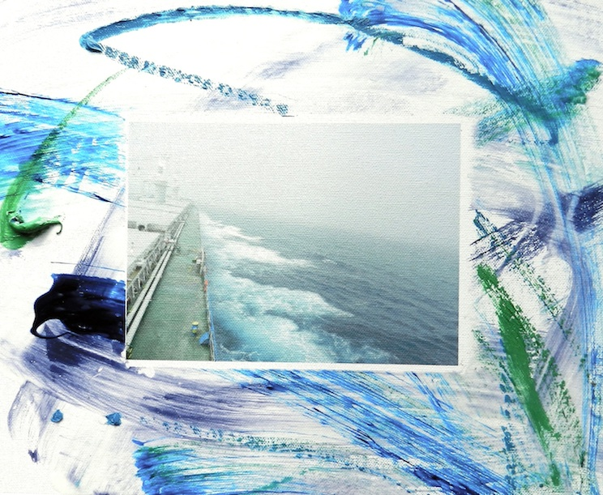

“Who in the rainbow can draw the line where the violet tint ends
and the orange tint begins?” – Herman Melville

During her journey aboard the Polish tramp steamer, Isolda, Italian artist Vittoria Chierici captured the movement and rage of the sea creating over 40 small paintings. Ms. Chierici was inspired by the sometimes rough waters of the British Channel, Atlantic Ocean, and the St. Lawrence River. On sunny days during the crossing she attempted to imitate the colors of the sea, capturing the many hues of cobalt blue that the sea possesses while seated at a small fixed table at the stern thought of by the artist as, “il tavolo del pirata.” It was these attempts at simultaneous imitation and expression of feeling that were the main concept developed in Ms. Chierici’s New York studio upon her return from sea.

About the Artist: Vittoria Chierici is a world renowned international painter and filmmaker, from Bologna, Italy. She temporarily works in New York where she has her studio. In the late ‘90s, Chierici began to work on a new mixed media project on the historical subject of The Battle of Anghiari, based on a lost mural by Leonardo Da Vinci. A large painting of the same subject, “Anghiari Verde”, is also permanently exhibited at New York University’s Humanities Initiative. Paintings and video installations by Vittoria Chierici have been shown in galleries and museums in Italy and abroad. She is represented by the art gallery, Lucie Fontaine, Milano.

Library@sunymaritime.edu

